Know When to Test Your Plan
Table Top Exercise: Power Outage Scenario

Exercise Date:
Next Exercise Date:
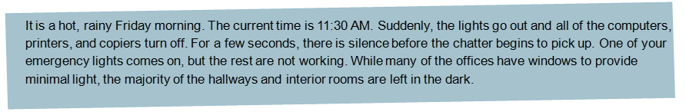
- Take the first 10 minutes to discuss what you will do next.

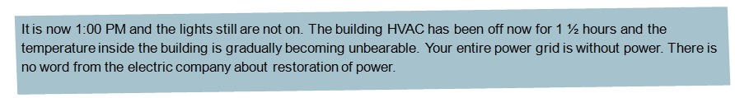
- Now what are you going to do?

- Is your technology/computer room being dealt with?
By whom?

- Has someone turned off all computers, printers, and equipment to prevent electrical surge when power is restored?

- Is your phone system down?

How are you going to manage the phone lines?

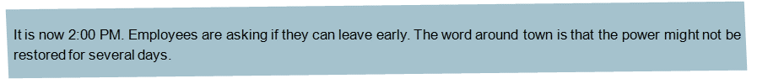
- How will you communicate this message?

- What instructions will you convey to your employees?
Customers?

Vendors?

- Are you going to declare a disaster in order to activate your business continuity plan?

Continue your discussion with the following questions:

- How are people within the organization communicating with each other (e.g., sending and receiving messages, information, and response details)?

- How are they communication with other stakeholders (e.g., your customers and clients, the media)?

- Is there a pre-determined and agreed upon central meeting place for company leaders, management, and employees?

- Is there a copy of your business continuity plan that you can easily retrieve?

- Are there any business processes for which there are manual workarounds?

If so, discuss how that would happen?

- How would you find an appropriate place to operate from for the remainder of the day?

For the next one or two weeks, if necessary?

- Have you begun an assessment that includes an evaluation of the status of employees, customers, operations, and external utilities?

- How would you ensure that customer concerns are managed?

- Have you begun to determine how much data was lost and how that will affect your operations?

- Some employees are asking, “How will I know if I should come to work Monday?”

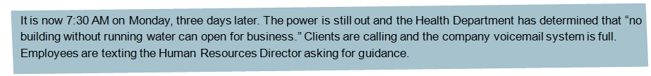
- What do you tell them?

Exercise Debrief:
- What is missing from your plan?

- What worked well in this scenario?

- What did not work so well?

- What could you do differently next time that would improve your response?

- List the actions you will take to improve your plans.

Exercise Wrap Up:
This completes the exercise. In order to maximize what can be learned from this effort, have all participants write down their thoughts and concerns. You can address these and the debrief issues at future meetings.

Notes:

