Often, businesses have particular equipment that serves as the primary source of a successful operation. If such equipment failed or was unavailable, the business may have to restrict production of goods and services or be forced to shut down. An example of this may be a printing press at a print shop or an oven at a bakery. Business owners should identify the key equipment and machinery necessary to perform critical business functions. You may also want to list company-owned vehicles.

When there is advance warning about an event, such as winter weather or a hurricane, you might decide to move key equipment and machinery to safeguard them from the approaching hazard or move them to be used at an alternate location. Since some disasters occur without advance warning, you should ensure you have identified available replacements or alternative options to continue operations.

When evaluating and identifying critical equipment and machinery, consider the following:
- In advance of a known weather event:
- Can the equipment be easily moved to a safe place in the building or to an alternate location?
- Can measures be taken to protect the equipment in its current location?
- Is the equipment customized or one-of-a-kind?
- How long would it take to reorder the equipment?
  - Is the equipment functional or obsolete? If obsolete, how long would it take to replace or get it functional?
- Are there rental resources to temporarily replace the critical equipment?
- Can you outsource the end product if the equipment cannot be substituted quickly?

Be sure to save and store any photos, purchase invoices, sales receipts, user guides, and warranty information in a dry and safe location. You should be able to access this information at any time during the event.

Knowledge of equipment exposures and the impact on your business operations is critical to properly manage the exposure. With this knowledge, you can plan ahead to help protect your business, employees, customers, and reputation.

Note: Use the Know Your Information Technology form to document IT-related equipment.

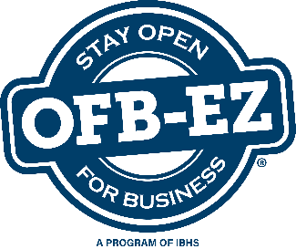
Know Your Equipment

Use this form to document key equipment, machinery and other items you will need to fulfill your critical business functions.
Updated:
Next Review Date:
Item:
Related Business Function Name(s):
Brief Description of Item:
Manufacturer:
Model No:
Serial No:
Asset Tag Number:
Quantity: Purchase/Lease Date: Purchased/Leased New or Used:
Price Paid:
Physical Location Within Facility:
Is this equipment replaceable? If so, how long to become functional? If not replaceable, what are your options?
Are there spare parts available? If so, explain.
Is vendor/manufacturer installation required?
Primary Supplier/Vendor:
Alternate Supplier/Vendor:
Order Time for Replacement:
Warranty or Service Contract Info:
(Attach photos)
Notes:

