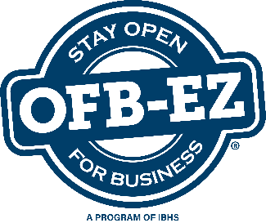
Know Your Finances

Updated:
Next Review Date:
Overall Business Needs
Have you worked with your bank to set up a line of credit for your company?
Who is responsible to activate it and who has access to it?
How much cash would be needed to survive a 3-day, 5-day, 10-day, or longer shutdown?
For what purpose is the cash needed? Will you have that cash on hand?
Who would make the decision to utilize the cash?
Who would have access to the cash?
Do you have sufficient cash to pay for various additional services that might be needed, such as janitorial or security services?
Do you have a company credit card that could be used for emergency purchases?
Who is authorized to use the credit card?
Will you be able to pay your bills/accounts payable?
Do you have procedures in place to accommodate a business disruption?
Will you be able to continue to accept payments from customers/accounts receivable?
Do you have procedures in place to accommodate a business disruption?
Have you identified an alternate location where you can work?
Human Resources
In the event of a widespread disaster, how will payroll be handled?
If your business is forced to shut down temporarily, will some or all employees continue to be paid?
For how long?
Will they be able to use their sick and/or vacation time without restriction?
Are there union considerations?
Have your employees been made aware of your policies that will be in place during a disruption?
If banks are closed, will your business provide payroll-cashing services?
What is your business’ policy on cash advances, check cashing, and employee loans?
Will your employees be expected to work overtime?

