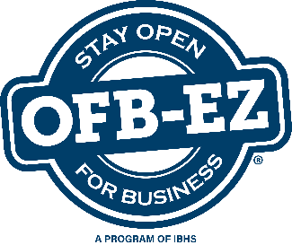
Know Your Equipment

Use this form to document key equipment, machinery and other items you will need to fulfill your critical business functions.
Updated:
Next Review Date:
Item:
Related Business Function Name(s):
Brief Description of Item:
Manufacturer:
Model No:
Serial No:
Asset Tag Number:
Quantity: Purchase/Lease Date: Purchased/Leased New or Used:
Price Paid:
Physical Location Within Facility:
Is this equipment replaceable? If so, how long to become functional? If not replaceable, what are your options?
Are there spare parts available? If so, explain.
Is vendor/manufacturer installation required?
Primary Supplier/Vendor:
Alternate Supplier/Vendor:
Order Time for Replacement:
Warranty or Service Contract Info:
(Attach photos)
Notes:

